Supporting Information

Reversible switching of electromagnetically induced transparency in phase change metasurfaces
Libang Mao¹, Yang Li^{1,2}, Guixin Li², Shuang Zhang³, and Tun Cao^{1,}*
1School of Optoelectronic Engineering and Instrumentation Science, Dalian University of Technology, Dalian 116024, China
2Department of Materials Science and Engineering, Southern University of Science and Technology, Shenzhen 518055, China
3School of Physics & Astronomy, University of Birmingham, Birmingham B15 2TT, UK

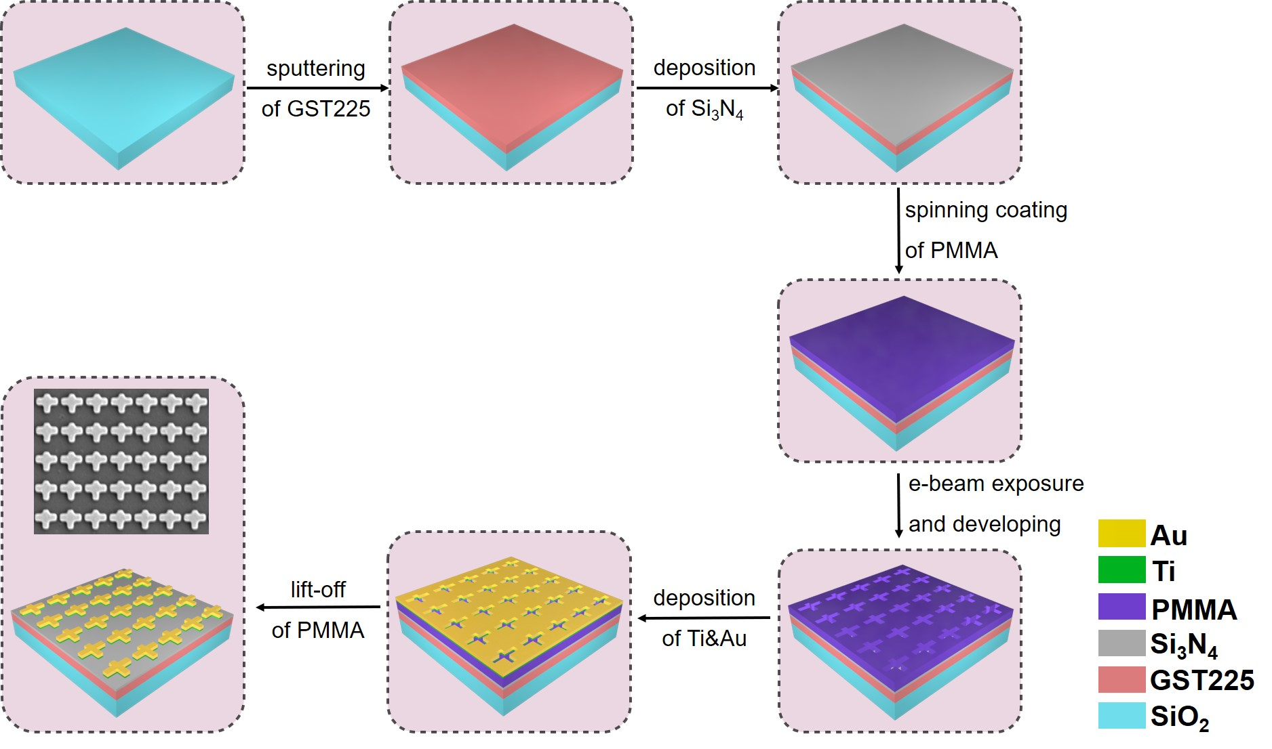
Figure S1. The fabrication scheme of the EIT phase-change metasurface.

Table S1. The fitting parameters for the transmittance spectra of the phase change metasurfaces using the coupled harmonic Lorentz oscillator model

 | ω₀ | δ | γ₁ | γ₂ | κ | g
AD-AM | 156 THz | 18 THz | 25 THz | 12 THz | 27 THz | -14 THz
CR | 137 THz | 18 THz | 22 THz | 51 THz | 1 THz | -9 THz

